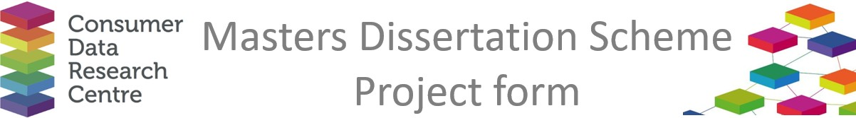

|  |  |
| --- | --- |
| **Company / Organisation Name:** | West Midlands Combined Authority |
| **Team / Department**: | Policy, Strategy and Innovation - Transport for West Midlands |
| **Address:** | 16 Summer Lane, Birmingham, B19 3SD |

**Provisional title for project:**

Analysing Cross-Boundary Bus Services in the West Midlands

**Short description of the problem that would be addressed by the project:**

The West Midlands is on the brink of a transformative period in public transport delivery. With potential changes in how bus services are managed, Transport for West Midlands (TfWM) could gain greater control over routes, fares, and service levels. This shift presents a unique challenge: effectively planning and operating bus services that cross the boundaries between the West Midlands metropolitan area and neighbouring regions. Understanding the usage, service levels, demographics, and economic impact of these cross-boundary services is crucial for making informed decisions that benefit the region's economy and its residents.

As part of this project, you will: 1. **Analyse Data**: Utilise a combination of TfWM data and open data sources, including the newly created Swift O-D trip dataset, to gather insights on cross-boundary bus services. **2. Assess Usage and Service Levels**: Investigate how well these services are used, the quality of service provided, and the demographics of the users. **3. Evaluate Economic Impact**: Determine the value these services bring to the West Midlands economy by analysing travel patterns and economic contributions. **4.Develop Recommendations**: Based on your findings, provide actionable recommendations to TfWM on how to optimise cross-boundary bus services.

The insights derived from your research will play a pivotal role in shaping the future of bus services in the West Midlands.

**Short description of the data sources that would be used in the project, and how they would be used**

Swift transactions, Swift O-D trips (Demand), Transxchange (Bus Network), Bus Open Data Service (Timetables)

**Would any work by the student need to be carried out on site at the Company with the exception of supervisory**

**meetings?**

No

**Any issues of data confidentiality and IPR that would need to be resolved**

No

**Essential skills**

Data analysis, Economic analysis, GIS analysis

**Desirable skills**

**Preferred degree programmes (if any)**

**Preferred selection method**

Online interview (Microsoft Teams)

**Support and training offered by the company**

The successful student will have support from a Senior Research Analyst who is familiar with the datasets used

**Financial assistance offered by the company**

The organisation will pay the honorarium (£500)

**Any other comments**

If there are any questions about the 2023 programme, please contact Richard Arnold at [richard.arnold@ucl.ac.uk](mailto:richard.arnold@ucl.ac.uk)