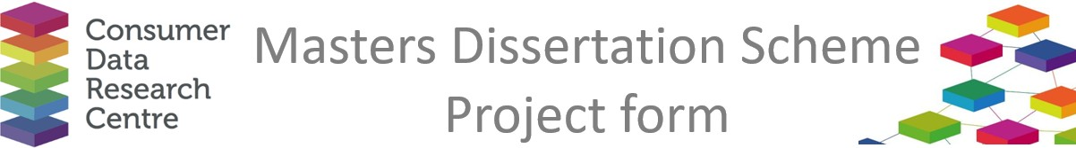

|  |  |
| --- | --- |
| **Company / Organisation Name:** | Knight Frank, MENA |
| **Team / Department**: | Research |
| **Address:** | Knight Frank MENA, Level 39, Media One Tower, Al Falak Street, Dubai Media City, Dubai - UAE |

**Provisional title for project:**

Rooftop solar power potential in the Middle East

**Short description of the problem that would be addressed by the project:**

Governments across the Gulf region are implementing ambitious plans to achieve net-zero carbon emissions by the middle of the century. As part of these efforts, large-scale solar arrays are being constructed on greenfield sites, reflecting the region's commitment to renewable energy. However, one potential resource that remains underutilised in these initiatives is the rooftop and car parking spaces on existing buildings throughout the Gulf. These spaces present significant, untapped potential for solar panel installations.

Rooftop and car parking areas provide ready-made surfaces for solar panel deployment, offering ideal spaces for solar arrays without the need for extensive land acquisition. Additionally, these spaces are often located near existing infrastructure, which can facilitate more straightforward connections to electricity grids, reducing the complexity and cost of integration. This setup could also present an opportunity for the installation of battery storage and the creation of a Virtual Power Plant (VPP), allowing excess electricity generated to be sold back to the grid. This not only supports the region's energy goals but could also serve as an income-generating strategy for landlords.

Furthermore, installing solar panels on these structures offers financial and market-driven benefits. Buildings with rooftop solar arrays are increasingly viewed as more sustainable and energy-efficient, which can make them more attractive to tenants. This can lead to higher rental incomes and increased property values, providing a competitive edge for landlords and building owners who position their assets as "green" or environmentally friendly.

Given the rising demand for sustainable buildings and the growing emphasis on renewable energy, the potential for solar energy generation from rooftops and car parks presents a valuable opportunity for the Gulf region. While the full scale of this potential remains relatively unknown, leveraging these spaces could play a significant role in achieving net-zero carbon targets. In doing so, it would not only contribute to environmental goals but also deliver economic benefits, further enhancing the region's overall sustainability efforts.

**Short description of the data sources that would be used in the project, and how they would be used**

Technology providers. Regional energy Ministries, Universities, etc

**Would any work by the student need to be carried out on site at the Company (with the exception of supervisory**

**Meetings)?**

Can be carried out remotely, with regular supervision/check-ins

**Any issues of data confidentiality and IPR that would need to be resolved**

All findings, or plans to publish the data/research externally would need to be first vetted by Knight Frank before being used externally.

**Essential skills**

ArcGIS, presentation skills, writing skills, Excel/R/Python expertise

**Desirable skills**

As above

**Preferred degree programmes (if any)**

Geospatial / data analytics

**Preferred selection method**

Zoom interviews to understand approach

**Support and training offered by the company**

Access to potential employment opportunities, exposure to a global blue-chip business and work experience with the Middle East’s leading real estate research team. Plus the opportunity to work on other projects, time permitting.

**Financial assistance offered by the company**

£500

**Any other comments**

The scope of the project would cover the cities of Dubai and Riyadh.

If there are any questions about the 2025 programme, please contact Richard Arnold at [richard.arnold@ucl.ac.uk](mailto:richard.arnold@ucl.ac.uk). The completed form should also be returned to this address.