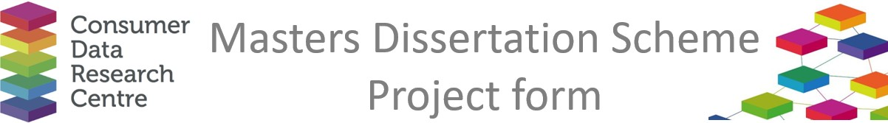

|  |  |
| --- | --- |
| **Company / Organisation Name:** | Liverpool City Region Combined Authority (LCRCA) |
| **Team / Department**: | Pipeline Development / Housing / Investment & Delivery Directorate |
| **Address:** | 1 Mann Island, Liverpool, L3 1BP |

**Provisional title for project:**

Transit-oriented development: modelling sustainable transport accessibility for new housing developments in Liverpool City Region

**Short description of the problem that would be addressed by the project:**

The continued interest in the “15-minute city” has prompted large bodies of empirical research about the availability of services in neighbourhoods, particularly those in new developments, which are often disconnected from existing transport infrastructure. Following recent policy changes and new government announcements, housing targets have increased significantly, prompting a need to explore the availability of brownfield land sites and other land-use for housing redevelopment across the Liverpool City Region. Furthermore, there is a keen interest to explore how these sites align with current and proposed transport infrastructure.

The LCRCA are taking a place-based approach to its funding and with the announcement of a single settlement, which takes effect in 2025/26, it is even more important that LCRCA demonstrates connections between housing, transport and investment to ensure that it is creating a place where people can live and work and travel sustainably. As such, LCRCA are keen to understand the types of brownfield land available, using Local Authority Brownfield Land Registers and Local Plans. Furthermore, they want to gain a better understanding of how these housing opportunities relate to existing transport infrastructure, by integrating small area accessibility metrics developed by the University of Liverpool. This will help us to pinpoint the sites which may have future issues with access to sustainable modes of transport. Similarly, LCRCA are also keen to understand additional development opportunities, for both housing and economic investment around transport hubs across the city region. By examining the distribution of existing land use around rail and bus estate across the city region, it will become possible, with data from Land Registry, to identify opportunities for development.

The outcomes of the project would be two-fold:

1. Better understanding of which brownfield land sites may need additional transport infrastructure to support development,
2. New evidence about alternative sites around existing transport hubs where investment could be prioritised for development.

The work would be used to support discussions with both local (principally internal LCRCA department and Local Authorities) and Government stakeholders (Homes England, Department for Transport and HM Treasury).

**Short description of the data sources that would be used in the project, and how they would be used**

* Local Authority Brownfield Land Registers to understand sites available for redevelopment.
* Local Authority Local Plans.
* Access to Transport small area measures developed by University of Liverpool
* LCRCA existing rail and bus estate data to help locate available land surrounding these assets which could be used for development opportunities.
* Land Registry Data to understand the landowner of the sites available for development opportunities surrounding existing rail and bus estate.

**Would any work by the student need to be carried out on site at the Company (with the exception of supervisory**

**Meetings)?**

No – work could be carried out remotely

**Any issues of data confidentiality and IPR that would need to be resolved**

No

**Essential skills**

Data science, data analysis, GIS

**Desirable skills**

Planning

**Preferred degree programmes (if any)**

Not specified by preference would be for data science, GIS or planning

**Preferred selection method**

Interview

**Support and training offered by the company**

One to one support and access to wider team within the LCRCA. Opportunity to work from LCRCA premises if required.

**Financial assistance offered by the company**

£500 upon completion

**Any other comments**

Outputs from the work should include GIS dashboards that can be used by LCRCA.

If there are any questions about the 2025 programme, please contact Richard Arnold at [richard.arnold@ucl.ac.uk](mailto:richard.arnold@ucl.ac.uk). The completed form should also be returned to this address.