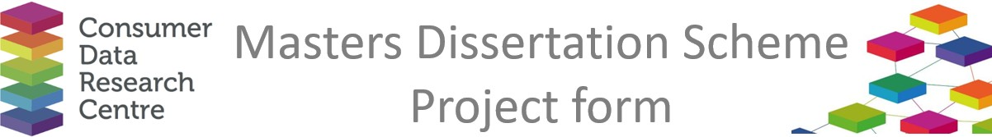

|  |  |
| --- | --- |
| **Company / Organisation Name:** | Temple Group |
| **Team / Department**: | Socio-Economics and Social Value |
| **Address:** | Temple Chambers, 3-7 Temple Avenue, Temple, London, EC4Y 0DA |

**Provisional title for project:**

Social Value measurement framework and tool development

**Short description of the problem that would be addressed by the project:**

Social value is an increasingly important approach to quantifying and measuring the net economic, social and environmental activities of an organisation or business. Social value enables business to articulate their approach to business in monetary terms and improves competitiveness in tenders and procurement processes.

The socioeconomics and social value team at Temple have been tasked with developing a social value framework and measurement tool for internal and potentially external use. We are hoping to leverage existing values in monetary frameworks such as MeasureUp (an existing social value measure bank – see [here](https://measure-up.org/values/)) or WELLBY (an econometric wellbeing measurement approach – see [here](https://www.stateoflife.org/wellby) and [here](https://www.simetrica-jacobs.com/news-and-views/newly-launched-green-book-supplementary-guidance-recommends-simetrica-jacobs-income-coefficient-to-measure-life-satisfaction)) and develop an automated system for measuring our social value activities. This would involve creating either an automated Excel spreadsheet/PowerBI dashboard, or other data visualisation tool. which draws on a data base or internal data source, to capture and report the social value that Temple delivers as a business. The internal database mentioned needs to also be created (this can be completed using SQL or any other database management software).

This is an opportunity to learn about social value in the context of a socially and environmentally impactful business and support the wider work of the socio-economic and social value team with your digital skills!

**Short description of the data sources that would be used in the project, and how they would be used**

Internal People and Learning data, monetary social value metrics, monetary wellbeing metrics.

**Would any work by the student need to be carried out on site at the Company (with the exception of supervisory**

**Meetings)?**

No, other than introductory meetings and progress workshops.

**Any issues of data confidentiality and IPR that would need to be resolved**

Yes, the data used is internal and sensitive, since it relates to Temple’s business activities, employees and staff. A waiver would need to be signed to ensure that the data used by the student remains confidential and managed appropriately. The finished framework and data tool would also be the property of Temple.

**Essential skills**

Proficient in data analysis, visualisation and database management using tools like Python, Excel, PowerBI, SQL, Microsoft Access. Interested in any of social impact, social value, ESG and wellbeing economics.

**Desirable skills**

It would be desirable if the student has experience in developing automated software solutions, in any context.

**Preferred degree programmes (if any)**

Computer Science, Data Science, Data Analytics, Software Engineering, Economics.

**Preferred selection method**

Interested candidates should write a short 150-word profile outlining their technical skills, previous experience of developing digital solutions and interest in social value/ESG/wellbeing economics.

**Support and training offered by the company**

You will receive guidance and support in learning about an emerging area of businesses in social value and wellbeing economics.

**Financial assistance offered by the company**

A stipend of £500 for the project is available.

**Any other comments**

No further comments.

If there are any questions about the 2025 programme, please contact Richard Arnold at [richard.arnold@ucl.ac.uk](mailto:richard.arnold@ucl.ac.uk). The completed form should also be returned to this address.