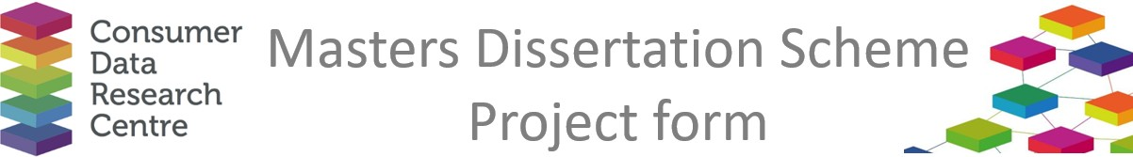

|  |  |
| --- | --- |
| **Company / Organisation Name:** | NOKIA Bell Labs |
| **Team / Department**: | Responsible AI Team, AI Research Lab |
| **Address:** | 21 JJ Thomson Avenue, CB3 0FA, Cambridge UK |

**Provisional title for project:**

How AI Challenges Company Missions

**Short description of the problem that would be addressed by the project:**

As organizations worldwide increasingly adopt AI, tensions can arise between the capabilities of these technologies and the core missions of these entities. These risks are not uniform - they vary significantly across sectors, geographic regions, and cultural contexts, creating unique challenges for each setting. The lack of insight into how these risks manifest geographically hampers proactive mitigation and informed decision-making. This work aims to shed light on these risks, emphasizing geographic trends and regional patterns to identify where AI adoption may pose the greatest conflicts with organizational missions.

**Short description of the data sources that would be used in the project, and how they would be used**

Through Nokia; to be discussed and confirmed.

**Would any work by the student need to be carried out on site at the Company (with the exception of supervisory**

**Meetings)?**

Not necessary.

**Any issues of data confidentiality and IPR that would need to be resolved**

To be discussed.

**Essential skills**

**Desirable skills**

Geospatial analysis, NLP, and data integration.

**Preferred degree programmes (if any)**

No particular preference.

**Preferred selection method**

Interview

**Support and training offered by the company**

Support will be provided by Nokia staff.

**Financial assistance offered by the company**

£500 stipend on successful completion of project.

**Any other comments**

If there are any questions about the 2025 programme, please contact Richard Arnold at [richard.arnold@ucl.ac.uk](mailto:richard.arnold@ucl.ac.uk).